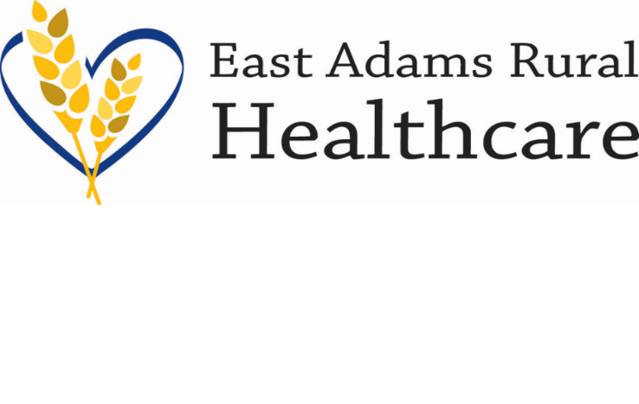
903 S Adams Ave. Ritzville, WA 99169
Office (509) 659-1200 Fax (509) 659-0632
www.earh.org

NOTICE

NOTICE IS HEREBY GIVEN that the meeting of the Board of Commissioners of Adams County Public Hospital District No. 2 will be held on Wednesday, February 28, 2024 at 5:30pm. The meeting will be held at East Adams Rural Hospital in the conference room downstairs and via Zoom. The information to call in is listed below.

Dial in +1-253-215-8782 USA Toll
Meeting number (access code): 880 2863 6262
Meeting password:145356

________________________
John Kragt, Chair
Board of Commissioners
East Adams Rural Healthcare

Posted Time: 9:00 a.m.
Date: February 14, 2024

